MINING HIDDEN PATTERNS IN MUSIC LISTENING DATA USING K-MEANS CLUSTERING

INTRODUCTION

Data mining and machine learning techniques are increasingly used to extract meaningful insights from large and complex datasets. One particularly useful category of techniques is clustering, which aims to group similar data objects together without predefined labels. Clustering has applications across many industries, including marketing, healthcare, finance, and digital entertainment.

APPLICATION SCENARIO

This study explores the applications of K-means clustering in the context of music streaming platforms. Specifically, the tool is applied to cluster songs based on their audio features and popularity to uncover hidden patterns in music characteristics and listener preferences.
Real world application for the use case could be a music streaming company aiming for better playlist recommendations, song suggestions, or music categorization. Instead of categorizing songs by genres or manually defined tags, clustering helps the company automatically categorize songs according to quantifiable parameters like energy, danceability, tempo, loudness, or popularity. Such clusters would further be utilized for creating mood-based playlists for, for example, highenergy workout tracks, relaxing background music, or for recommending tracks that may lack commercial success despite having desirable qualities.
This application can be regarded as novel in the context that it combines song-level clustering based both on audio and popularity attributes, as opposed to genre classification and user-driven recommendation systems, which are more commonly addressed in the current literature.

TOOL SELECTION AND JUSTIFICATION

The data mining technique used in this context is K-means clustering. Kmeans can be appropriately used in this context because of following reasons:
- It is suitable for numerical data like the audio feature variables in this case.
- It is computationally efficient and can handle many songs.
- It yields easily interpretable results in the form of clusters, which helps in understanding business-oriented results like playlist generation and recommendation systems.
- It is widely utilized in the industry and provides easier dissemination of results to the end audience.
Technology: Index of Industry-related Research Papers. With all these benefits, K-means clustering is suitable method for evaluating music listening activity data.

DATASET DESCRIPTION
The data used for this assignment is generated from an open music dataset that contains data for each music piece and its corresponding audio features. The data was supplied in a CSV file and merged into during the preprocessing phase. The final data set encompasses over 50 observations for the songs as required for the assignment.
The data consists only of numeric attributes, which makes it appropriate for clustering analysis. Every row within the data corresponds to a distinct song, whereas every column corresponds to distinct song, whereas every column corresponds to a quantifiable feature.

DATA VARIABLES
After cleaning and processing, the final dataset to be used in clustering analysis includes the following variables:
track_duration: The duration of the current song in milliseconds.
energy: The level of intensity and activity, with higher values reflecting tracks with higher levels of energy tempo: Actual tempo of the song in beats per minute (BPM) loudness: int – Overall loudness of track in units of decibels (dB) popularity_score: The popularity score of the song. This is a numerical measure of
The variable “track_id” was employed initially for merging the datasets and removed before the process of clustering, since K-means algorithms can work with only numerical inputs for the features.

DATA PREPARATION AND CLEANING

Before the application of the clustering algorithm, several preprocessing was done:
- Merging datasets:
Two CSV files were merged with a common key (track_id) so that the audio features and popularity score of each song would be matched properly.
- Removing non-numerical data:
The song names and their identifiers were removed as variables for clustering, as they are not involved in calculating numerical distance.
- Handling scale differences:
Since variables like tempo, loudness, and popularity scale very differently, min-max normalization was used these features. This meant that a variable like popularity would not overshadow the rest because of its large scale.
Finally, the cleaned and standardized data is stored in an Excel file, which is further analyzed in Python for clustering.

POTENTIAL INSIGHTS FROM THE DATASET

By applying K-means clustering to this dataset, several insights can be generated:
- Identification of distinct song profiles based on musical characteristics
- Understanding how popularity aligns (or does not align) with certain audio features
- Discovery of clusters representing different listening contexts (e.g., energetic vs. calm music)
- Support for data-driven playlist creation and recommendation strategies

APPLICATION OF K-MEANS CLUSTERING
The cleaned and normalized dataset was processed in Python (using
Google Colab) with libraries including K-means clustering was done in Python using libraries such as pandas, scikit, and matplotlib Python was chosen to execute this phase of the research because of its robustness, replicability, and suitability in machine learning algorithms. The process of clustering involved the following steps:
- Loaded the cleaned and normalized dataset
- Select the feature columns with integer values
- Find out the best number of clusters using the Elbow Method
- Apply K-means clustering with number of clusters selected
- Use clustering tools to analyze and interpret the clusters

DETERMINING THE NUMBER OF CLUSTERS

To determine which value of K will be suitable as the number of clusters, the “Elbow Method” was employed. This means that K-means clustering algorithms were conducted using different values of k
K (ranging between 1 to 9) and the related values of inertia.
The graph for the elbow method indicated a steep reduction in inertia for values k=1 through k=3, followed by a gradual reduction for values beyond k=3. There is a slowing down in growth for values beyond k=4, which corresponds to the start of a plateau.
On this basis, k=4 was determined to be the best values for k in k-means clustering since it strikes a balance between simplicity and explanatory power.
The Elbow Method plot used to determine the optimal number of clusters is shown in Appendix B, Figure 1.

CLUSTERING RESULTS AND INTERPRETATION

Applying K-means clustering with a total of four clusters, each song can now be classified under one of the following general categories:
Cluster 1: Upbeat popular songs
The song in this grouping is likely to be high in energy, louder in volume, and relatively popular. These songs are ideal for sport or party playlists.
Cluster 2: Moderate-energy mainstream tracks
It contains songs with relatively balanced audio properties and levels of popularity, thereby covering music that is generally accessible to listen to.
Cluster 3: Low Energy/Low Tempo tracks
This is the group of songs that are less energetic compared to the other ones and can quieter as well. This kind of music is used for background playlists when one wants to relax or concentrate.
Cluster 4: Less Popularity and Strong in Music
This group consists of those songs that have intriguing sound properties such as high danceability or tempo scores, though lower popularity scores. Such songs symbolize possible exploration and promotion.
A visual representation of the resulting clusters is provided in Appendix C, Figure 2.

NOVELTY AND SIGNIFICANCE

The novelty of this application is in merging the musical properties with the popularity to unearth patterns at the song level. Contrary to the traditional genre classification, this approach allows for:
- Discovery of Hidden Similarities within the Genre Suggestions:
- Identification of underrated songs with good musicality
- Content curation through data without the need for subjective tags
In a practical sense, the outcomes are highly important for music services seeking to enhance engagement and variety in musical recommendations through unsupervised learning.

CONCLUSION

This work showed the successful application of the K-means clustering technique in the analysis of music listening habits to identify hidden meaningful patterns. By carefully preparing, normalizing the data, and evaluating the clusters, clear groupings of songs were identified based on their audio features and popularity.
These findings thus underline the importance of clustering both as an exploratory data analysis tool and for decision support in the context of digital entertainment. The current study could be further expanded by including additional types of data on listeners’ behavior, by using different methods of clustering, to model overlapping music preferences.

APPENDIX A
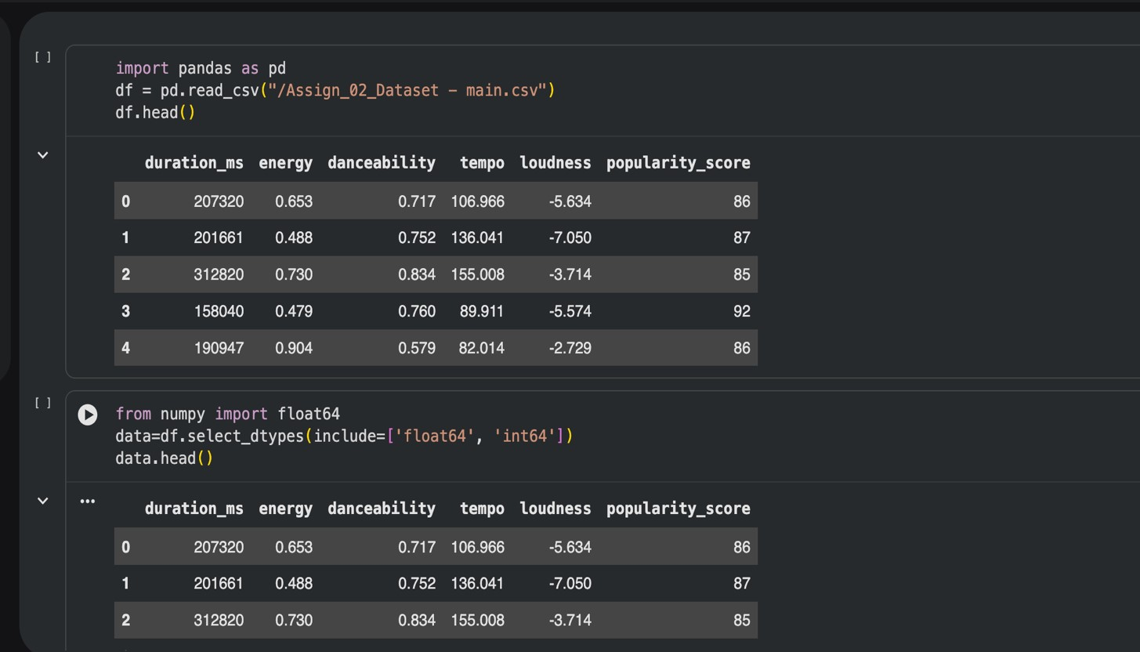
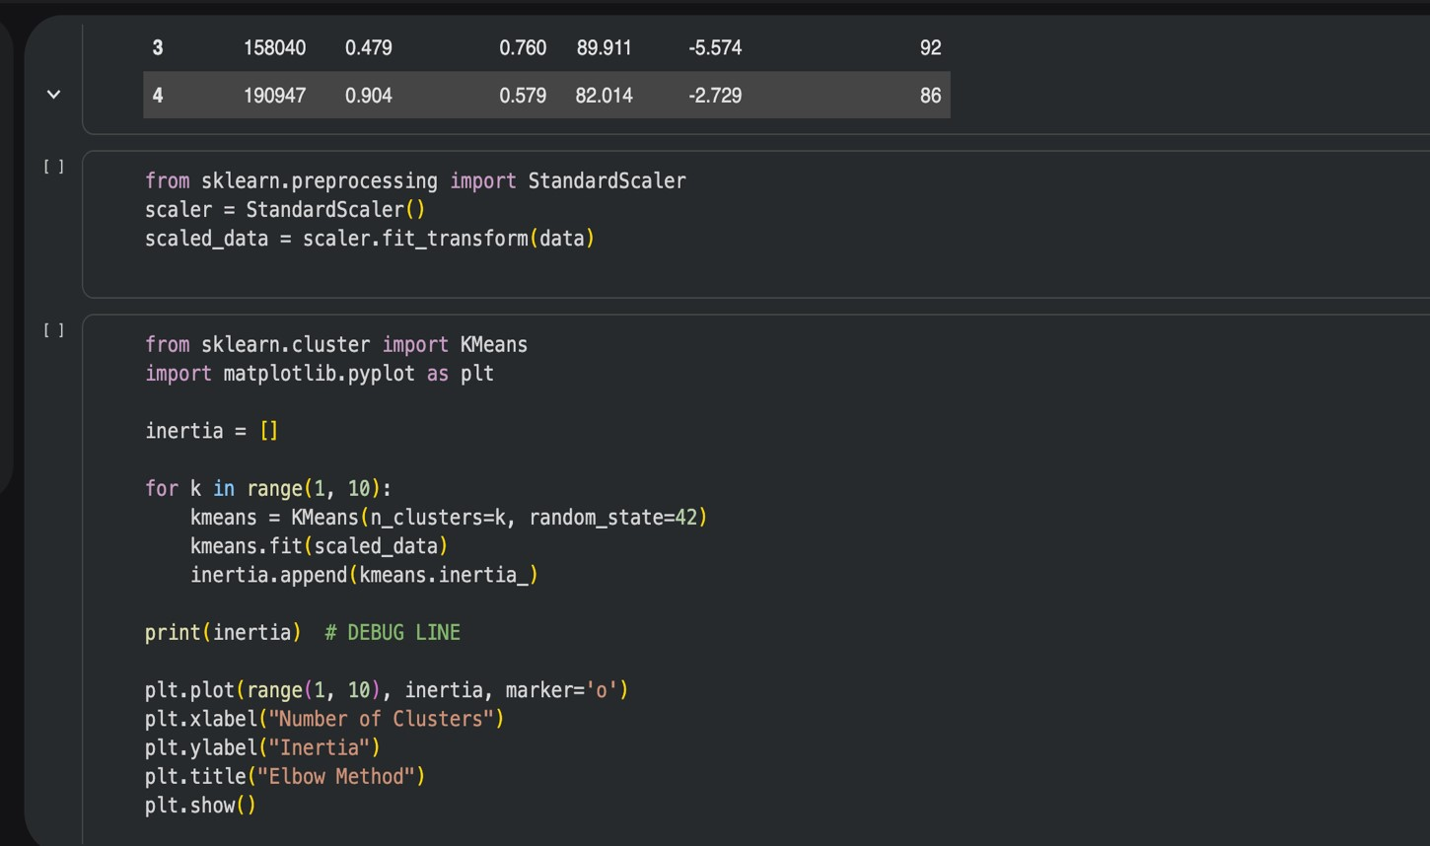
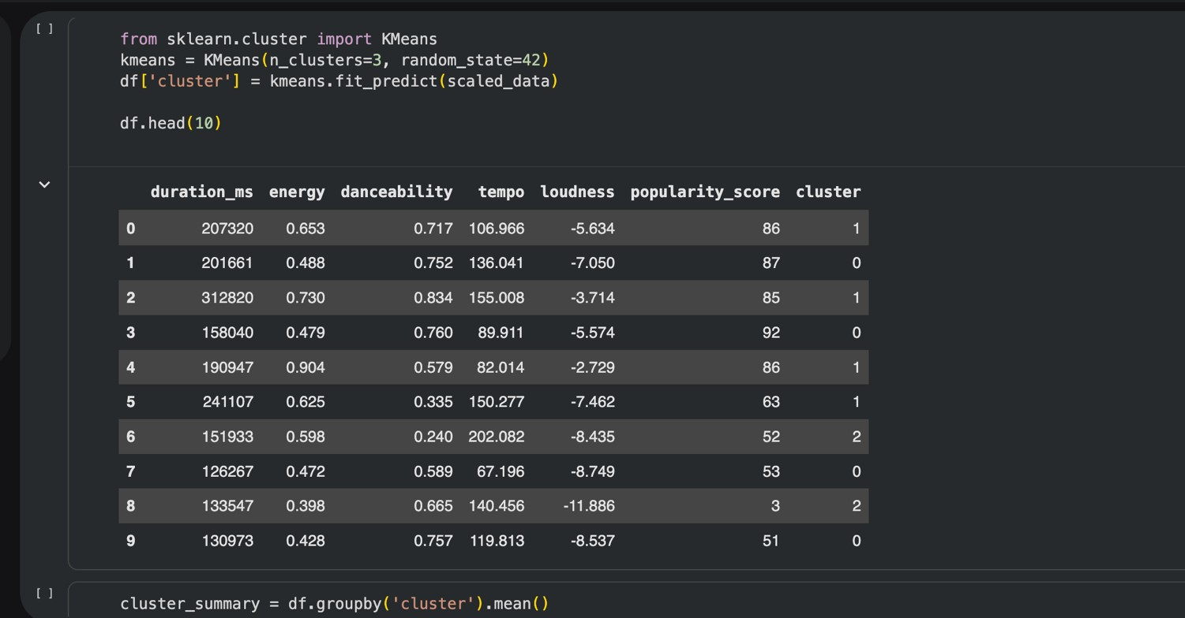
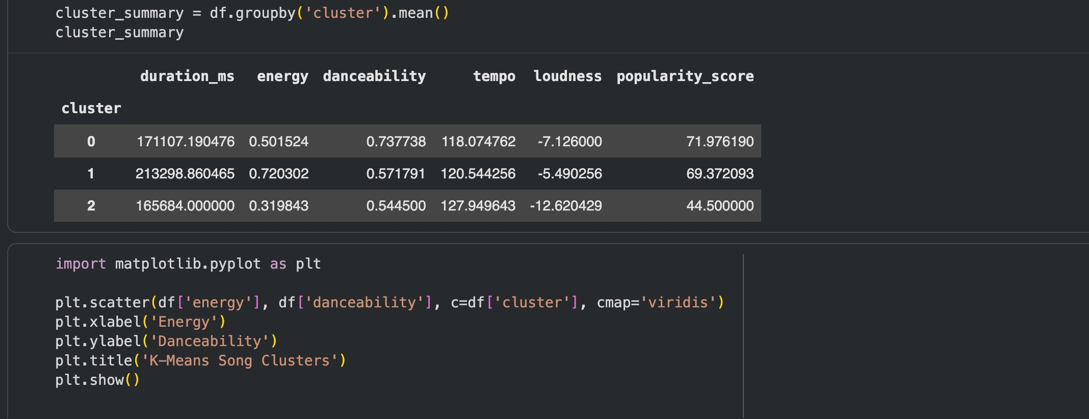

APPENDIX B

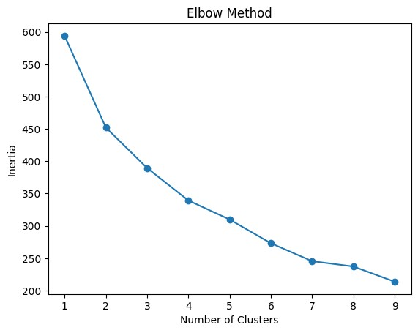

FIGURE 1

APPENDIX C

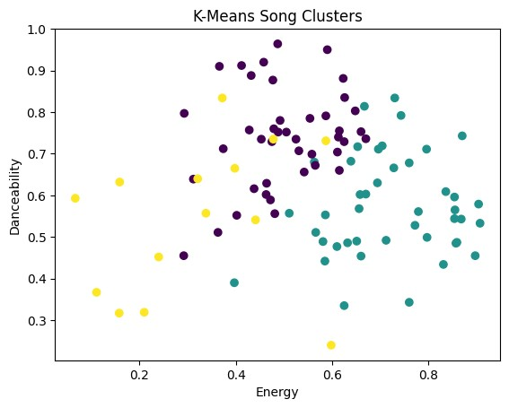

FIGURE 2

REFERENCES
- ScienceDirect. (2025). Data Mining: Concepts and Techniques. [online] Available at:
https://www.sciencedirect.com/book/monograph/9780123814791/data-mining-conceptsand-techniques.

- Silva, M.O., Mota, L. and Moro, M.M. (2019). MusicOSet: An Enhanced Open Dataset for Music Data Mining. Zenodo (CERN European Organization for Nuclear Research). [online] doi:https://doi.org/10.5281/zenodo.4904639.

- Spotify (2025). Web API Reference | Spotify for Developers. [online] developer.spotify.com. Available at: https://developer.spotify.com/documentation/web-api/reference/get-audiofeatures.

